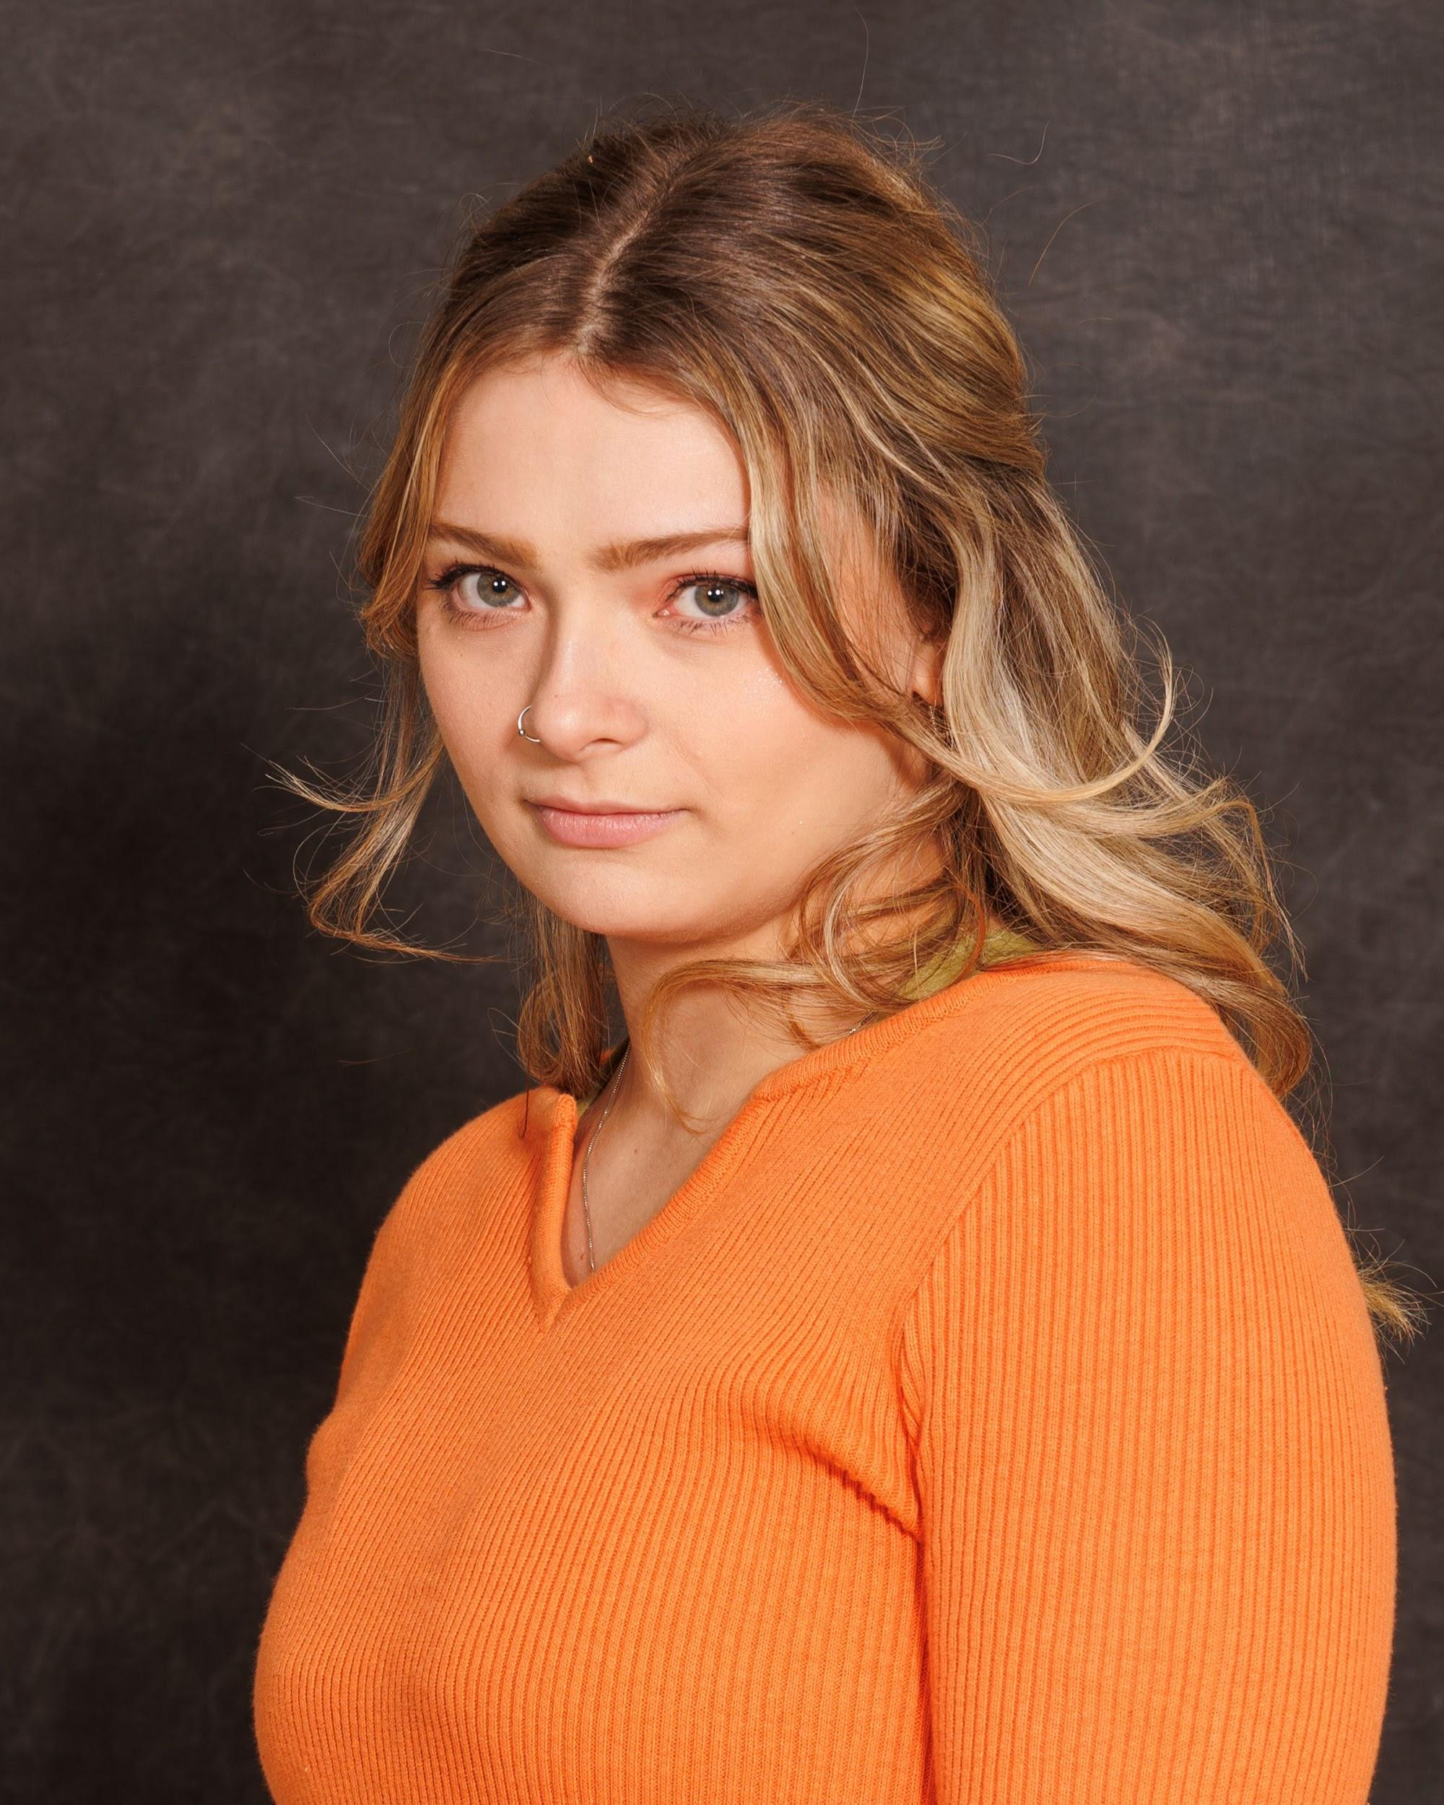

Victoria Rousseau

Non-Union

Hair: Dirty Blonde | Eyes: Green | Height: 5‘7 |

Vocal Range: Mezzo Soprano

victorialrousseau[@gmail.com](mailto:Victorialynrouss2@gmail.com) **| (978) 609-2902**

**STAGE EXPERIENCE**

*Dead Man’s Cellphone* Jean (Lead) Post Theatre Company

*Spring Diversity* Dancer Post Concert Dance Company

*Narnia* Susan (Lead) Methuen High School

*Spring Awakening* Dress Ensemble/Anna Swing Cue Zero Theatre Company

*Almost Maine* Ginette Dramatically Incorrect Theater

**DEVISED WORKS**

**—————————————————————————————————————————————***It Takes A Moment*  Devisor Post Theatre Company

**CHOREOGRAPHY**

**—————————————————————————————————————————————***Shrek: The Musical* Methuen High School/Joanie Walsh

*Dis(CONNECT)ed* Post Theatre Company/Maria Porter

*Spring Awakening*  Cue Zero Theatre Company/Jake Zentis

*Seasons 25-26*  Onstage Dance Company/Jennifer Kuhnberg

**TRAINING**

**—————————————————————————————————————————————Long Island University Post - BFA in Musical Theatre (Class of 2020)**

Suzuki/Meisner (Maria Porter), Stanislavski/Chekov (David Hugo), Voice (Michelle Mallardi), Voice & Speech (Michael Colby Jones), Acting on Camera/Film (Robbie Tan), African Dance (Fritzlyn Hector), Musical Theatre Dance (Rachel Bertone)

**Center for Performing Arts Dance Studio & Acting School (2008-2016)**

Ballet/Pointe/Jazz/Competition Dance (Michelle Mitchitson), Tap (Nicole Surette), Contemporary/Modern/Hip-Hop (Melanie Capalbo), Acting/Theatre (Rebecca Farnham)

**American Academy of Ballet Summer School of Excellence (2015)**

Ballet (Iain Macdonald), Spanish Dance (Ricardo Santiago), Folk Dance (Vladimir Stadnik)

**SPECIAL SKILLS:**

**————————————————————————————————————————————**

Dialects: British, Australian, Boston/Massachusetts.

Physical Skills: Cartwheels, Right/Left/Middle splits, Double turn on right, Right/Left tilt (+ jump)**,** Physical theatre (Composition), Immersive Theatre.

Valid U.S. Driver’s License. 11 years experience working with children ages 2-18 years old.